Exercise 1: Control Structures

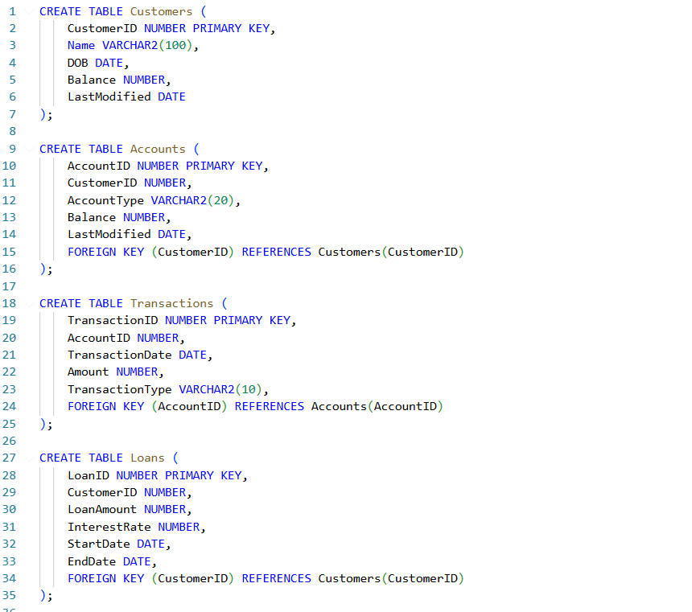
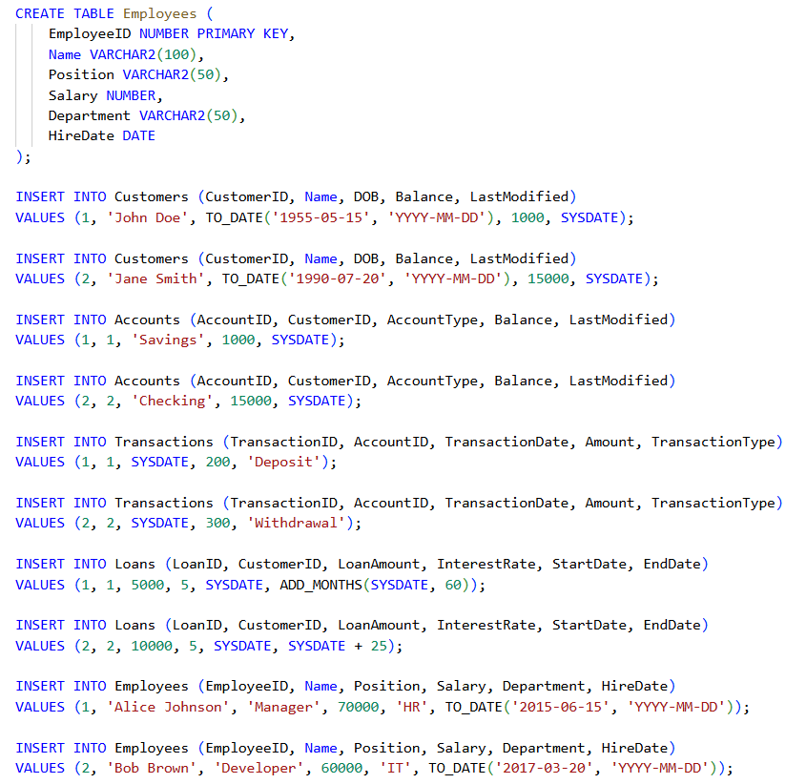
Scenario 1: The bank wants to apply a discount to loan interest rates for customers above 60 years old.

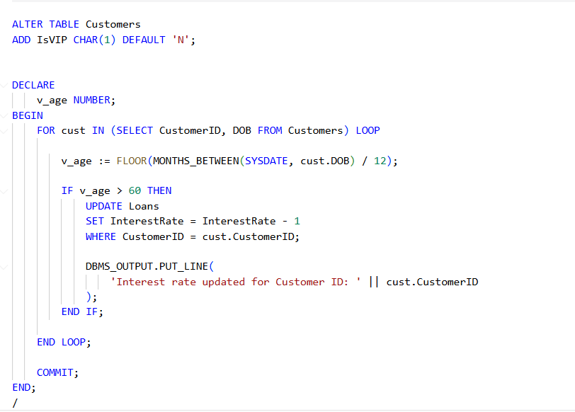
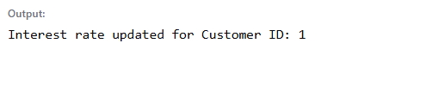
Scenario 2: A customer can be promoted to VIP status based on their balance.

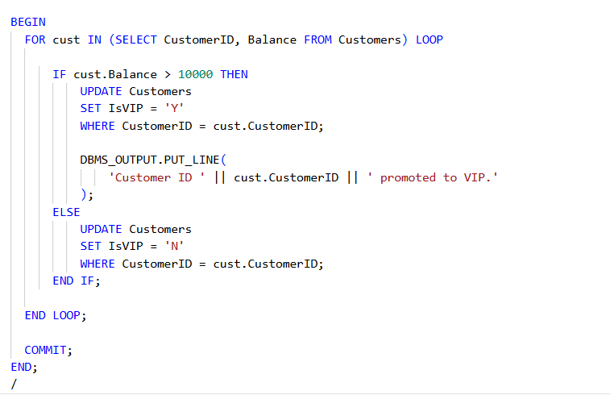
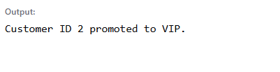
Scenario 3: The bank wants to send reminders to customers whose loans are due within the next 30 days.

